PROJECT REPORT

Project Name : AI-Based DDoS Detection and Real-Time Banking Network Monitoring System

Team members
- INUKURTHI SAI VISHVITHA 23BCB7056
- KORITALA SAI LAKSHMI 23BCB7112
- THANDAYAM SANDHYA 23BCB7195
- BULLA SAI MANIDEEP 23BCB7295


AI-Based DDoS Detection and Real-Time Banking Network Monitoring System

1.Problem Identification
The banking sector increasingly depends on digital services such as internet banking, mobile banking, online fund transfers, payment gateways, and other web-based financial services. The continuous availability of these services is essential because service disruption can affect a large number of customers and financial transactions.
One of the major cybersecurity threats affecting online services is the Distributed Denial of Service (DDoS) attack. In a DDoS attack, an attacker uses multiple compromised devices or sources to generate a large volume of traffic towards a target server or network. This excessive traffic can consume network bandwidth and system resources, causing legitimate users to experience slow response times or service unavailability.
Traditional DDoS detection approaches often use predefined rules, fixed thresholds, or signature-based techniques. Although these methods can identify known attacks, they may be less adaptable when network traffic patterns change or when attacks use different characteristics.
Therefore, the main problem identified in this project is:
How can suspicious network traffic and potential DDoS attacks be automatically detected and monitored in a banking-related network environment using machine learning and real-time traffic analysis?
The system should also provide administrators with a centralized platform to monitor traffic, detected attacks, alerts, and historical attack information.

2. Proposed Solution
The system will analyze network traffic and use a Machine Learning model to classify the traffic as:
- Normal Traffic
- Suspicious/DDoS Traffic
When suspicious traffic is detected, the system will record the event and display relevant information through an administrative monitoring dashboard.
Working of the Proposed System
- Network traffic data will be obtained from a publicly available DDoS dataset and/or captured in a controlled environment.
- Important network traffic features will be extracted.
- The data will be cleaned and preprocessed.
- Machine Learning algorithms will be trained using labelled normal and DDoS traffic.
- The best-performing model will classify traffic as normal or suspicious/DDoS.
- Prediction results will be sent to the backend.
- Traffic logs and attack information will be stored in the MySQL database.
- The React dashboard will display:
  - Traffic statistics
  - Number of detected attacks
  - Alerts
  - Attack history
  - Risk levels
- Suspicious source information can be flagged, with an optional simulated response/blocking mechanism for demonstration purposes.

Proposed System Workflow

Network Traffic / Dataset
↓
Packet and Traffic Analysis
↓
Feature Extraction
↓
Data Preprocessing
↓
Machine Learning Model
↓
Normal / DDoS Prediction
↓
Risk Level Assessment
↓
Flask Backend
↓
MySQL Database
↓
Real-Time Monitoring Dashboard
↓
Alerts and Attack History

3. Innovation / Improvement Over Existing Systems
The improvement proposed in this project is the integration of multiple security monitoring functions into a single system designed as a banking-sector monitoring prototype.
Proposed Improvements
1. Integrated Monitoring System
Instead of developing only an ML classification model, the project integrates:
- Network traffic analysis
- Machine Learning-based detection
- Backend APIs
- Database logging
- Real-time dashboard monitoring
- Attack alerts
- Attack history and analytics
2. Machine Learning-Based Detection
The system will compare suitable Machine Learning algorithms and select a model based on evaluation metrics such as:
- Accuracy
- Precision
- Recall
- F1-Score
This helps select an appropriate model for the chosen dataset.

3. Risk-Level Assessment
In addition to displaying only Normal or DDoS, the system can categorize suspicious activity into levels such as:
- Low
- Medium
- High
- Critical
This provides administrators with easier interpretation of detected events.
4. Centralized Attack Logging
All important traffic and attack events will be stored in a centralized MySQL database. This allows administrators to analyze previous incidents and observe patterns.
5. Real-Time Administrative Dashboard
The system will provide a web-based dashboard to visualize:
- Total traffic records
- Normal traffic
- Detected attacks
- Recent alerts
- Attack trends
- Historical attack information

Innovation Statement
The proposed system improves conventional standalone DDoS detection approaches by integrating machine learning-based traffic classification, network traffic analysis, centralized logging, risk-level assessment, alerts, and a real-time web dashboard into a single modular prototype for banking-sector network monitoring.
4. Tools and Techniques Used
Software and Technologies
Category | Tool/Technology | Purpose
Programming Language | Python | ML, packet processing and backend
Frontend | React with Vite | Web application and dashboard
Backend | Flask | REST API and application logic
Database | MySQL | Store traffic and attack records
Database Tool | MySQL Workbench | Database management
Machine Learning | Scikit-learn | Train and evaluate ML models
Data Analysis | Pandas | Data preprocessing
Numerical Processing | NumPy | Numerical operations
Model Storage | Joblib | Save and load trained model
Network Processing | Scapy | Packet analysis/capture in controlled testing
Network Analysis | Wireshark | Analyze network traffic
API Testing | Postman | Test backend APIs
Version Control | Git and GitHub | Source code management
IDE | Visual Studio Code | Development environment

Machine Learning Techniques
The following algorithms will be considered and compared depending on the dataset and results:
- Decision Tree
- Random Forest
- Gradient Boosting
The best model will be selected based on:
- Accuracy
- Precision
- Recall
- F1-Score
- Confusion Matrix

Data Processing Techniques
The dataset will undergo:
- Data cleaning
- Missing-value handling
- Duplicate removal
- Feature selection
- Categorical data encoding where required
- Feature scaling where required
- Training and testing data splitting

Potential Network Features
Depending on the selected dataset and available traffic information, features may include:
- Source Port
- Destination Port
- Protocol
- Packet Length
- Flow Duration
- Packet Count
- Bytes per Second
- Packets per Second
- TCP Flag Information
The final feature set will be selected after dataset analysis.

5. Major Modules of the Project
The project will be divided into four major modules.
Module 1: AI/ML and DDoS Detection
- Research DDoS attacks
- Select a suitable dataset
- Data preprocessing
- Feature engineering
- Train multiple ML models
- Evaluate model performance
- Select the best model
- Save the trained model
- Develop a reusable prediction module
- Test packet/traffic feature extraction in a controlled environment

Module 2: Backend and API Integration
- Develop Flask backend
- Implement authentication
- Create REST APIs
- Integrate the ML prediction module
- Process prediction requests
- Connect with MySQL
- Generate alerts
- Manage traffic and attack logs
- Implement error handling

Module 3: Database Module
- Design database schema
- Create required tables
- Store user information
- Store traffic logs
- Store attack logs
- Store alerts
- Store flagged/blocked IP information
- Prepare SQL queries
Module 4: Frontend and Monitoring Dashboard
- Develop login interface
- Develop administrator dashboard
- Display traffic information
- Display attack information
- Display alerts
- Display attack history
- Add charts and statistics
- Integrate with backend APIs
- Develop responsive user interface

6. Project Architecture
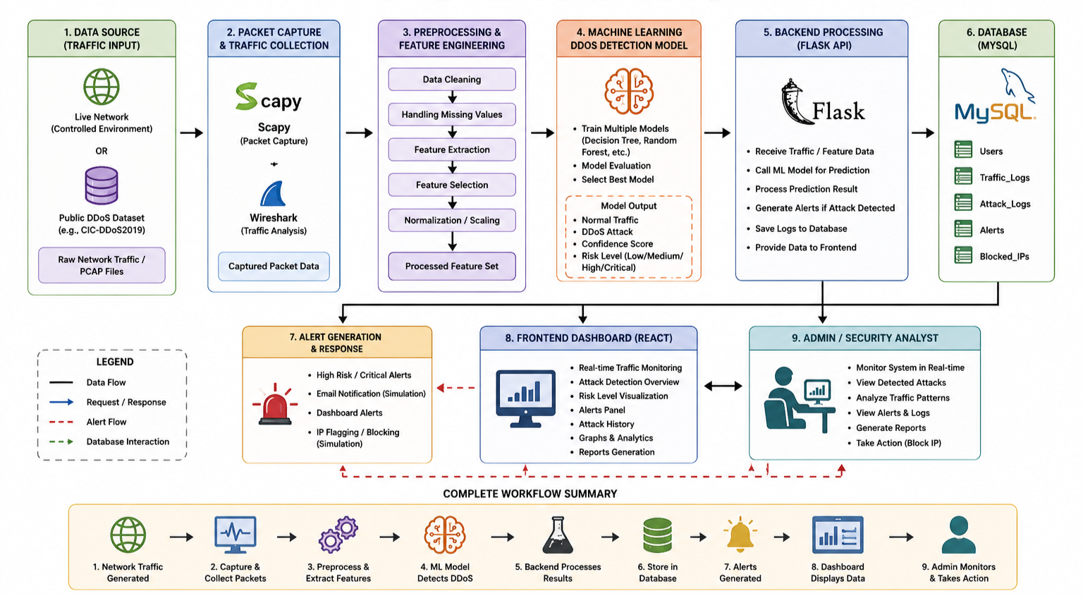
7. Timeline of the Project
Proposed 12-Week Timeline
Week | Planned Activities | Expected Outcome
Week 1 | Problem identification and research | Problem statement
Week 2 | Study DDoS attacks and select dataset | Dataset selection
Week 3 | Data cleaning and preprocessing | Processed dataset
Week 4 | Feature engineering and analysis | Selected features
Week 5 | Train ML models | Initial models
Week 6 | Evaluate and select best model | Trained model
Week 7 | Traffic/packet analysis module | Feature extraction workflow
Week 8 | Flask backend and API development | Backend APIs
Week 9 | MySQL database development | Database integration
Week 10 | React dashboard development | Frontend interface
Week 11 | Full module integration and testing | Working prototype
Week 12 | Documentation, testing, PPT and demonstration | Final project

Expected Outcome
The expected outcome of this project is to develop an AI-based DDoS detection and banking network monitoring system.
The system will:
- Detect Normal and DDoS traffic using Machine Learning.
- Analyze network traffic and identify suspicious activities.
- Store traffic and attack details in a MySQL database.
- Generate alerts when a potential DDoS attack is detected.
- Display traffic statistics, detected attacks, and alerts on a web-based dashboard.
- Maintain attack history for future analysis.
- Provide a simple risk-level assessment for detected attacks.
The project aims to provide a centralized system for detecting and monitoring potential DDoS attacks in a banking network environment.

